SNAKE RIVER WESTERN SHOOTING SOCIETY
2013 – WEEKEND SHOOT SCORES
Newest to Oldest
December 28, 2013
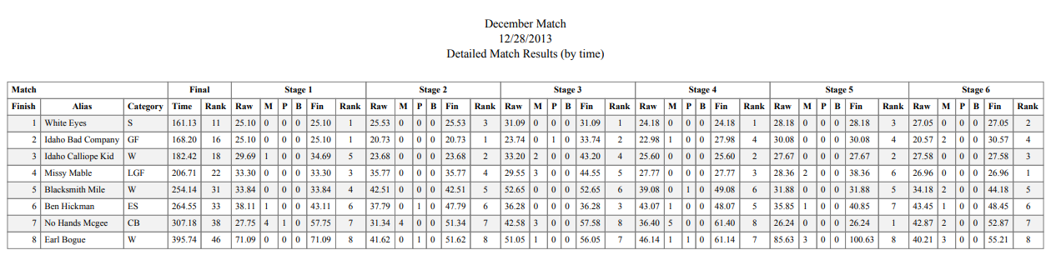
November 23, 2013
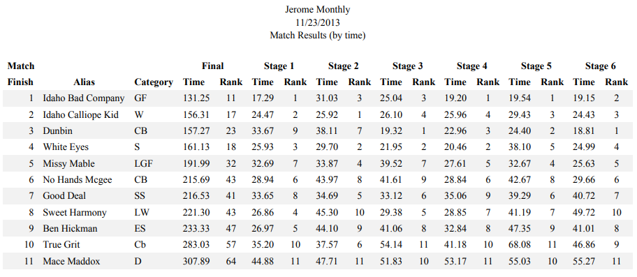
October 26, 2013
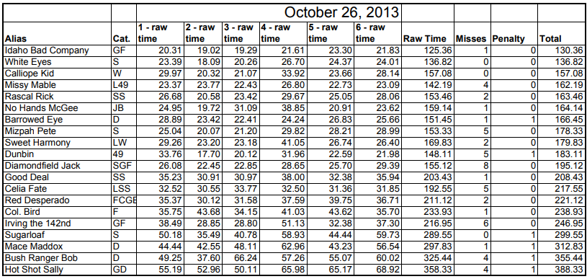
September 28, 2013
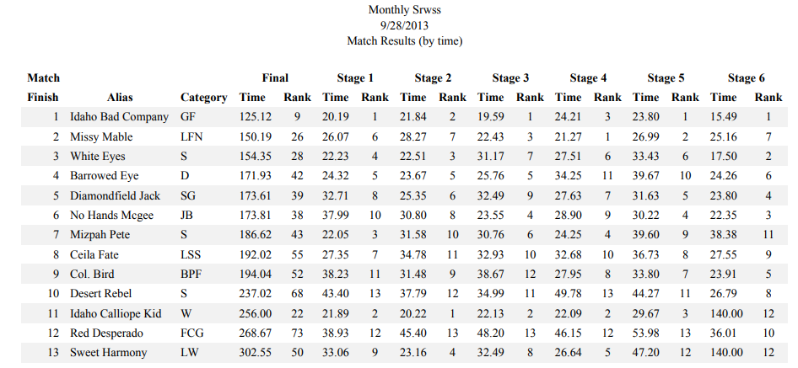
August 24, 2013
August 18, 2013
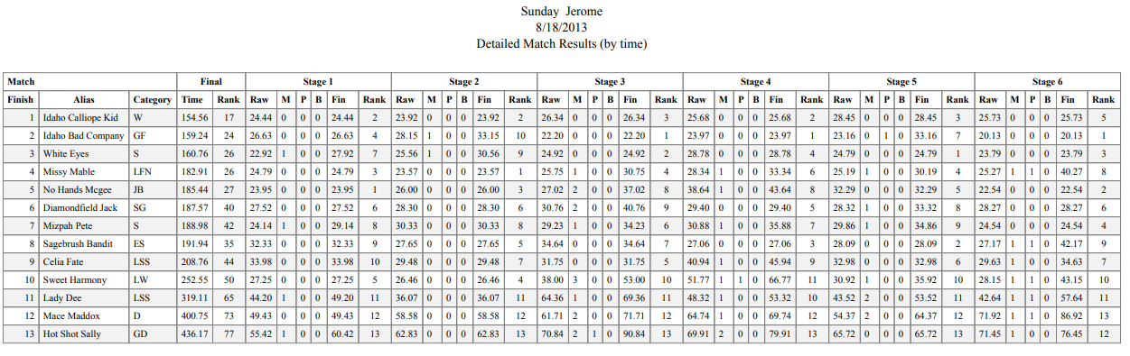
July 27, 2013
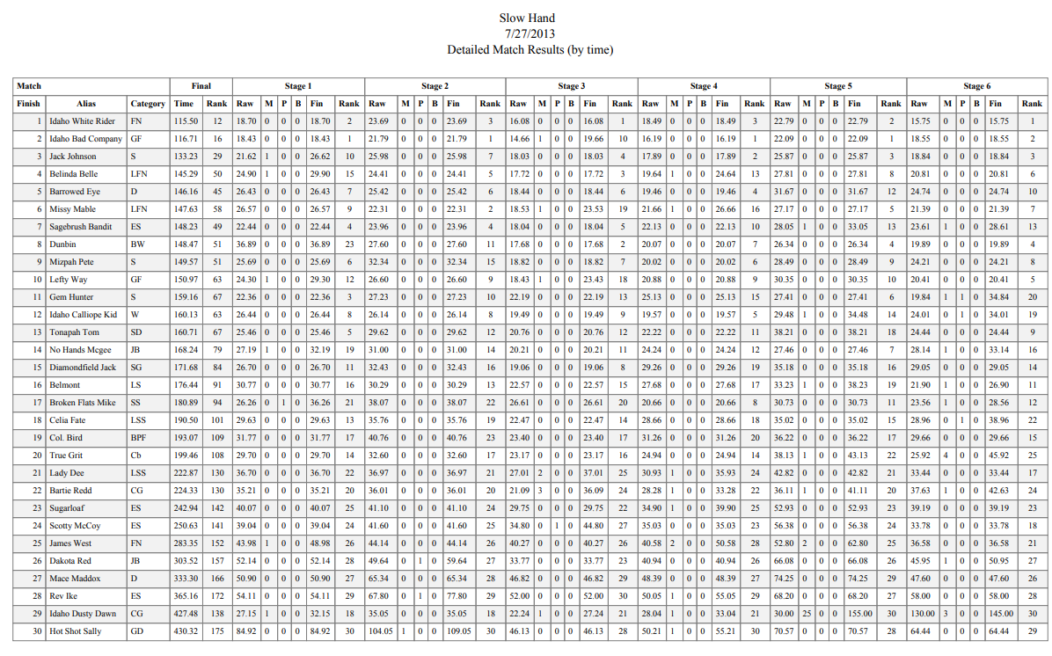
July 14, 2013
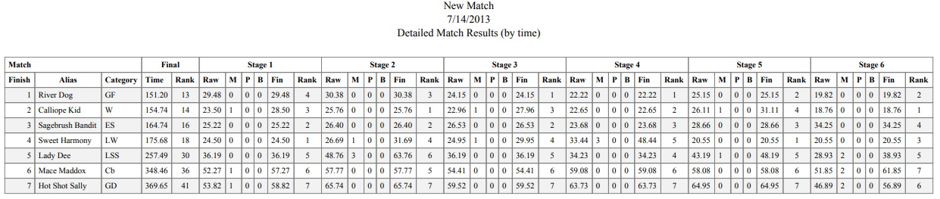
June 22, 2013
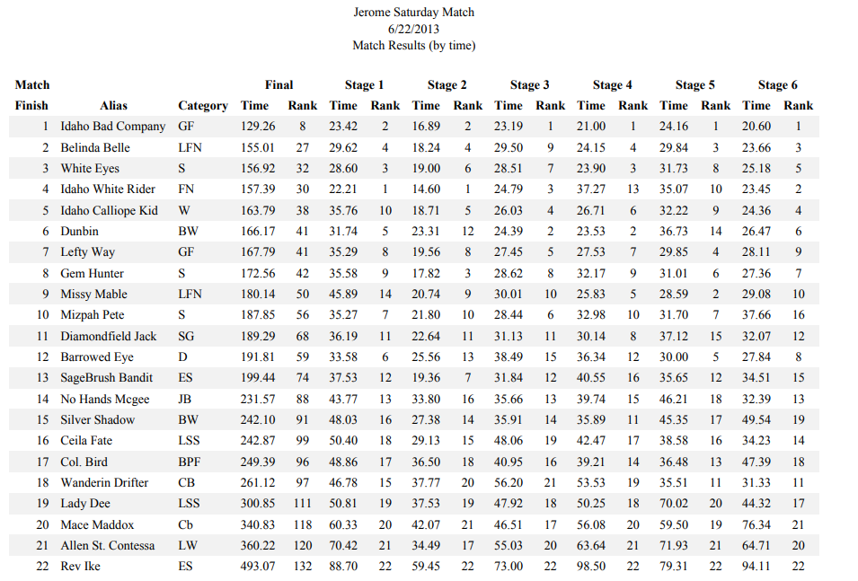
June 16, 2012
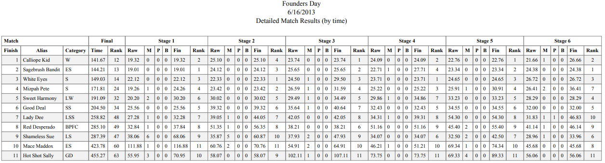
May 19, 2013
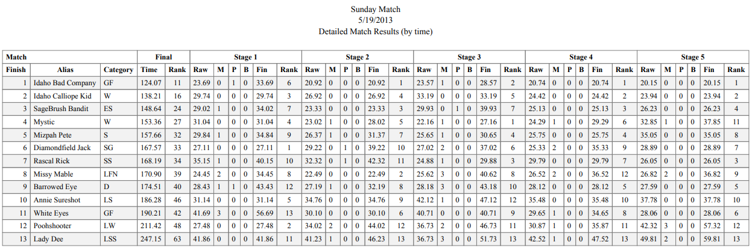
April 27, 2013
April 21, 2013
March 23, 2013
