SNAKE RIVER WESTERN SHOOTING SOCIETY
2014 – WEEKEND SHOOT SCORES
Newest to Oldest
October 25, 2014
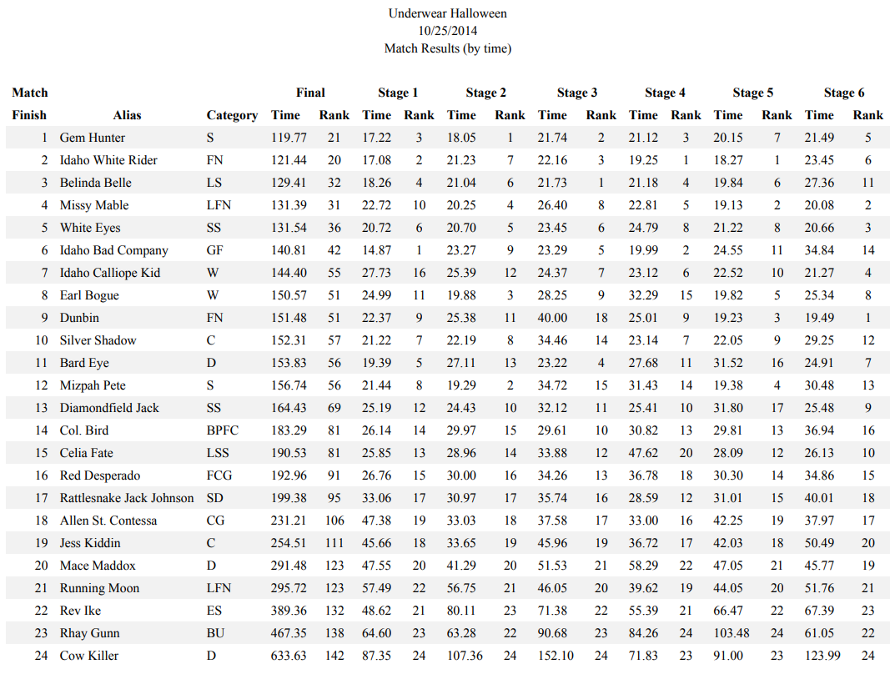
September 27, 2014
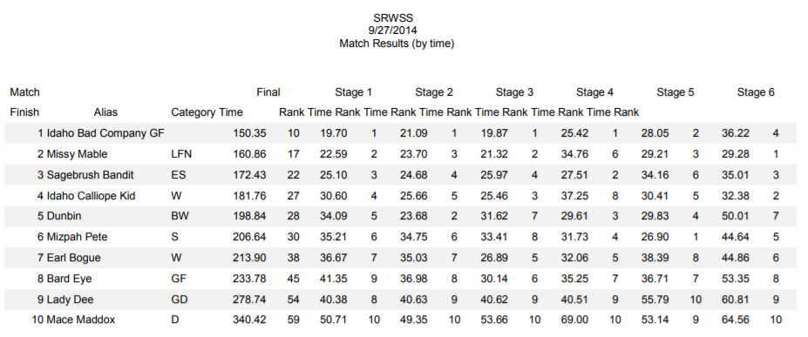
August 23, 2014
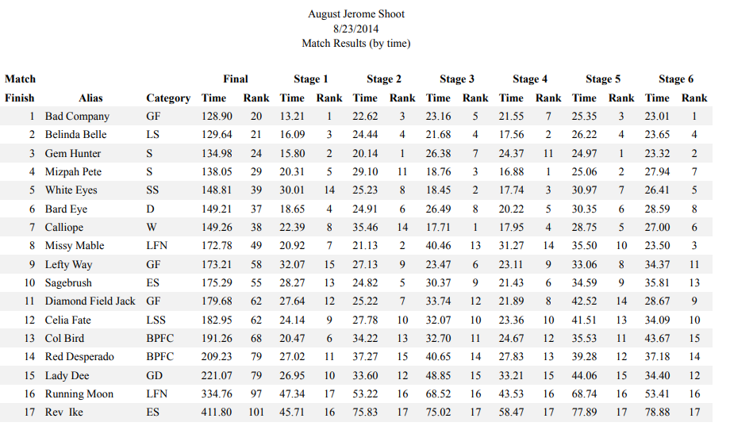
August 17, 2014
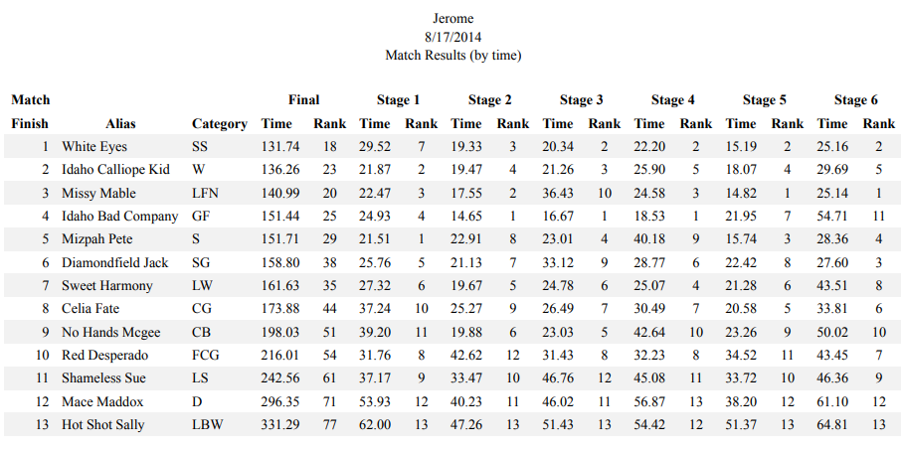
July 26, 2014
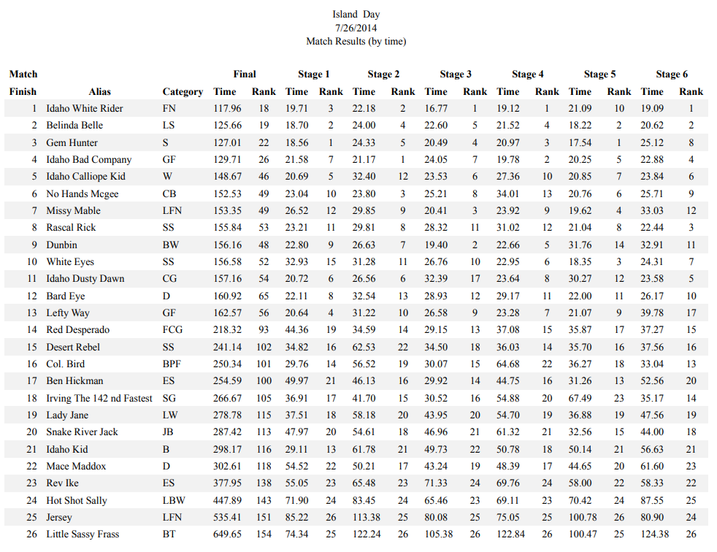
July 20, 2014
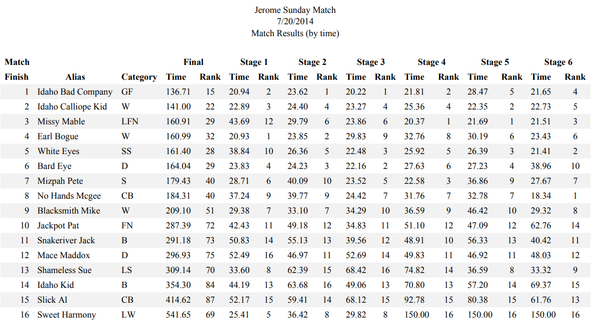
June 28, 2014
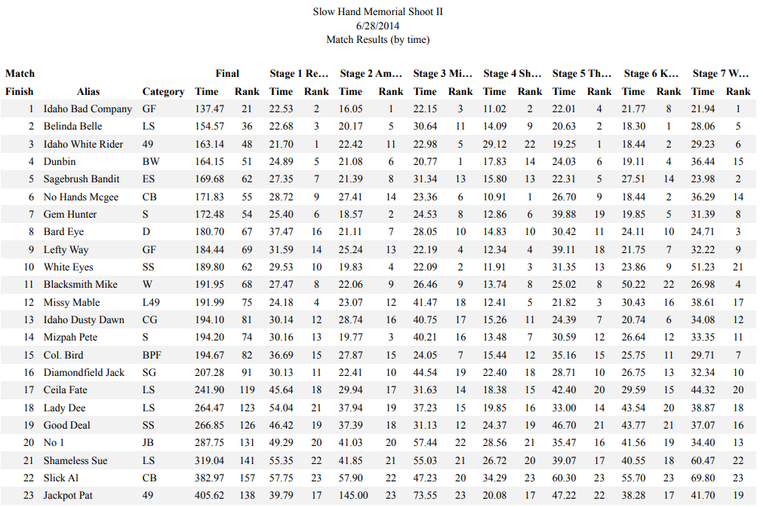
June 15, 2014
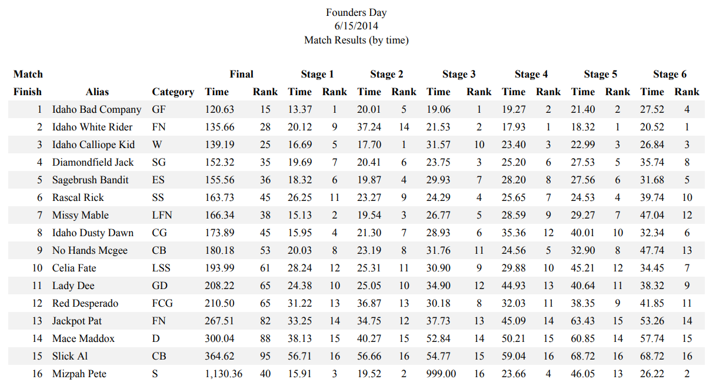
March 22, 2014
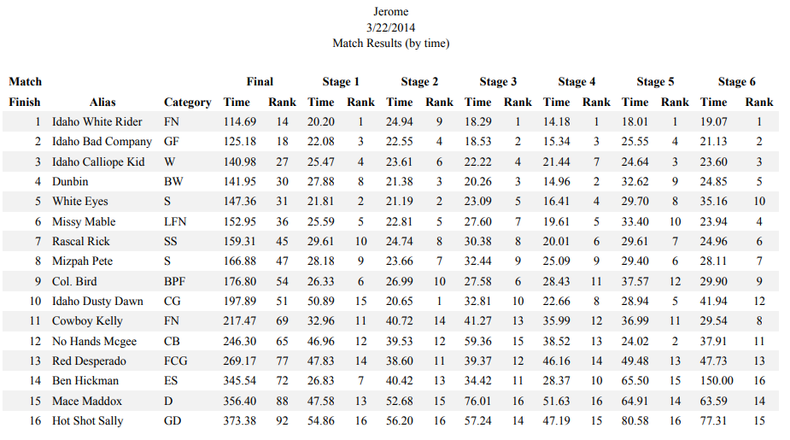
February 22, 2014
January 25, 2014
