SNAKE RIVER WESTERN SHOOTING SOCIETY
2015 – WEEKEND SHOOT SCORES
Newest to Oldest
October 24, 2015
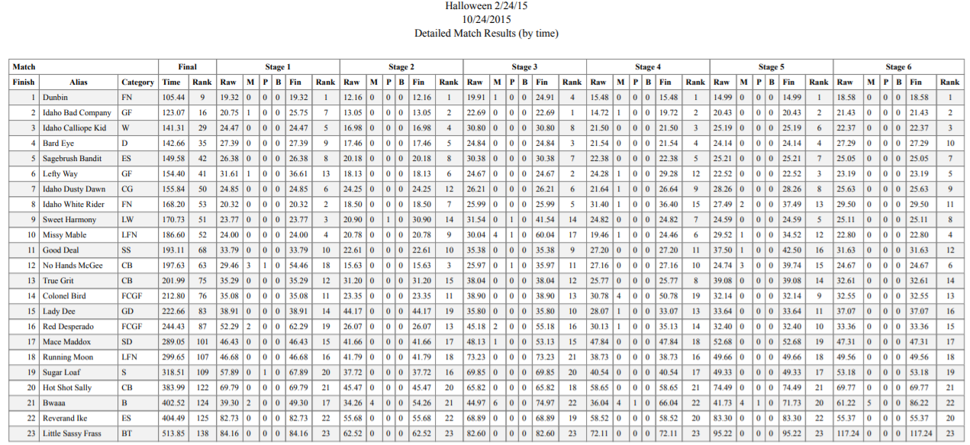
October 18, 2015
September 26, 2015
August 22, 2015
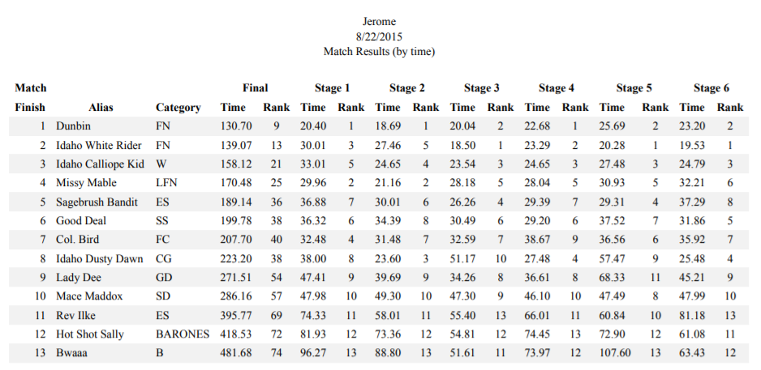
July 25, 2015
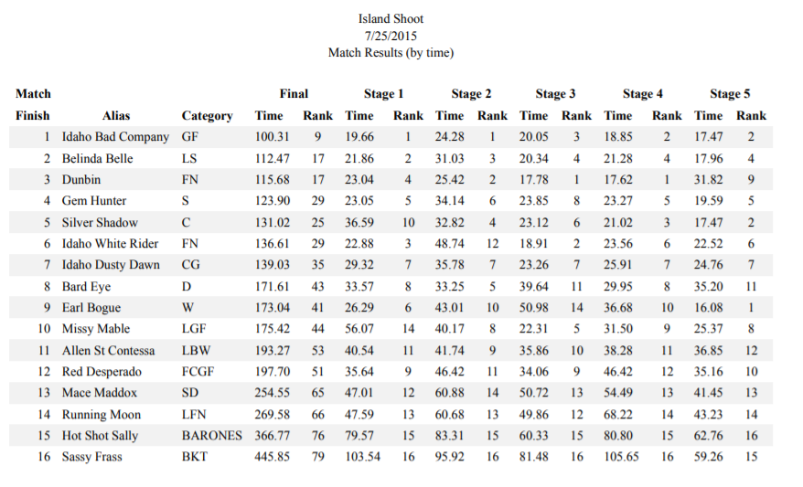
July 19, 2015
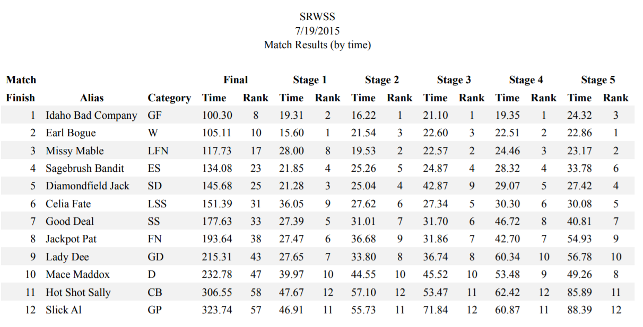
June 27, 2015
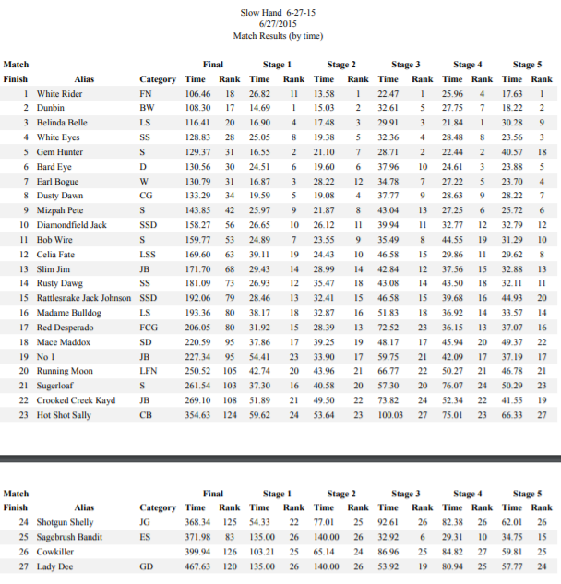
June 21, 2015
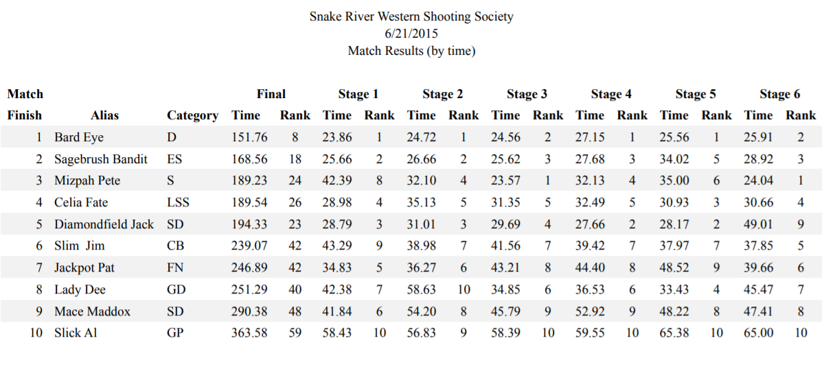
April 25, 2015
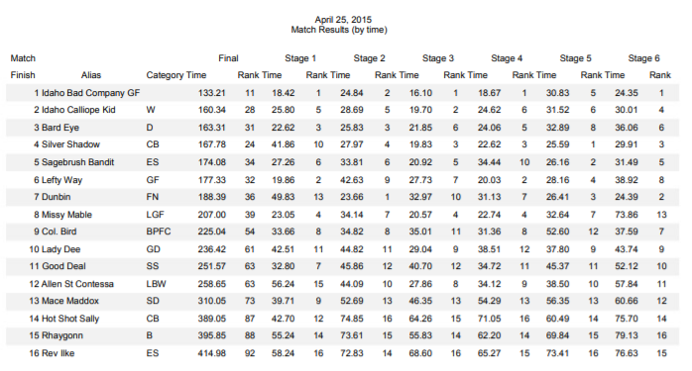
April 19, 2015
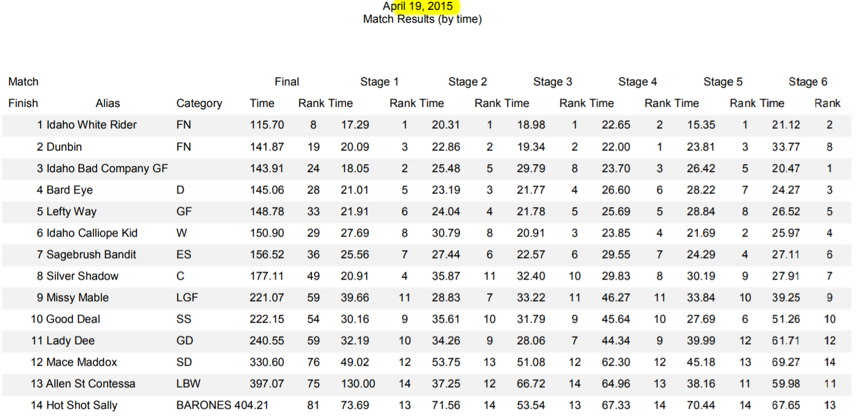
March 14, 2015
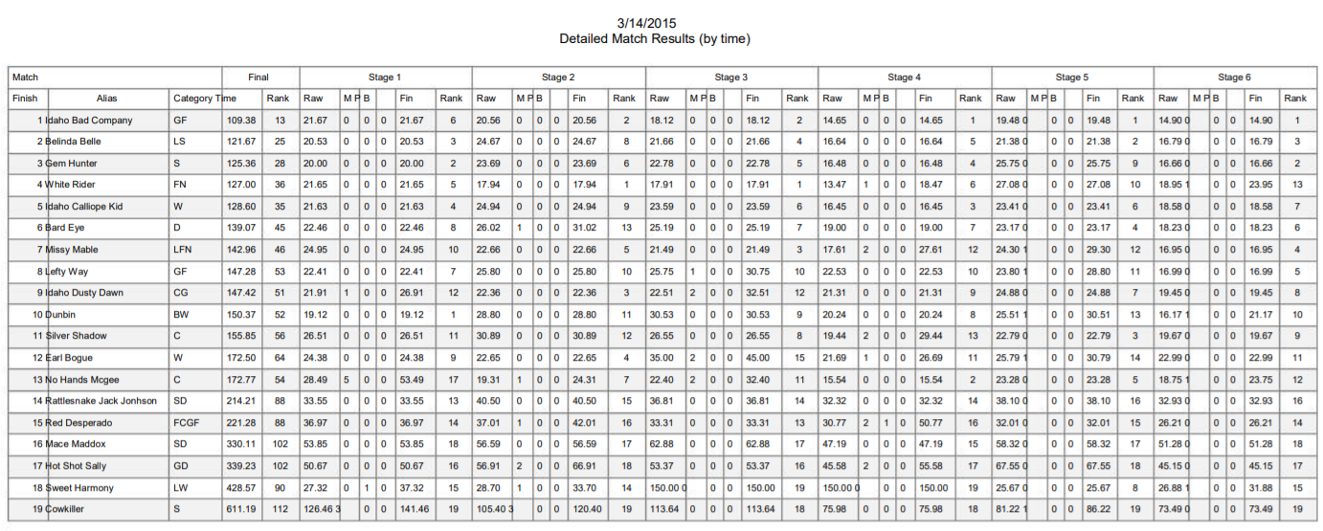
February 14, 2015
