SNAKE RIVER WESTERN SHOOTING SOCIETY
2016 – WEEKEND SHOOT SCORES
Newest to Oldest
October 22, 2016
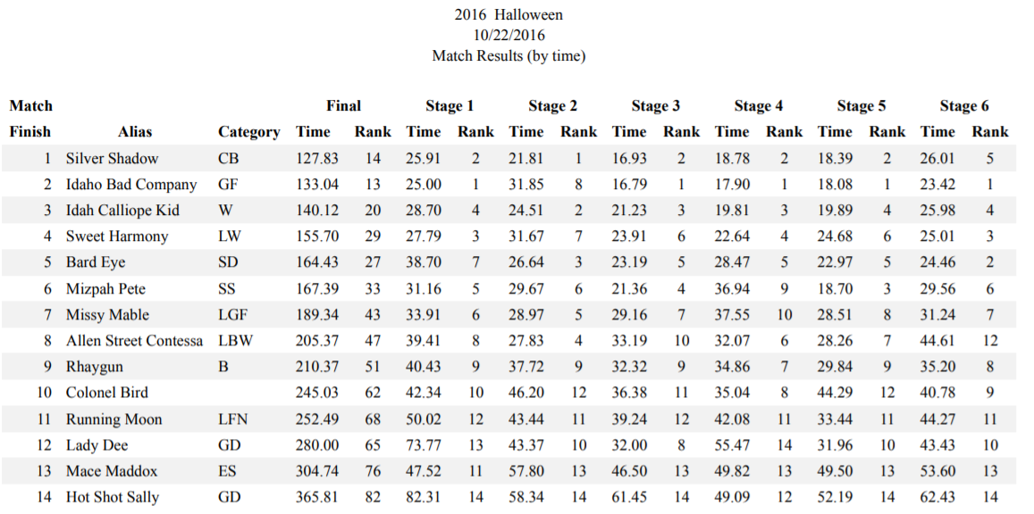
September 25, 2016
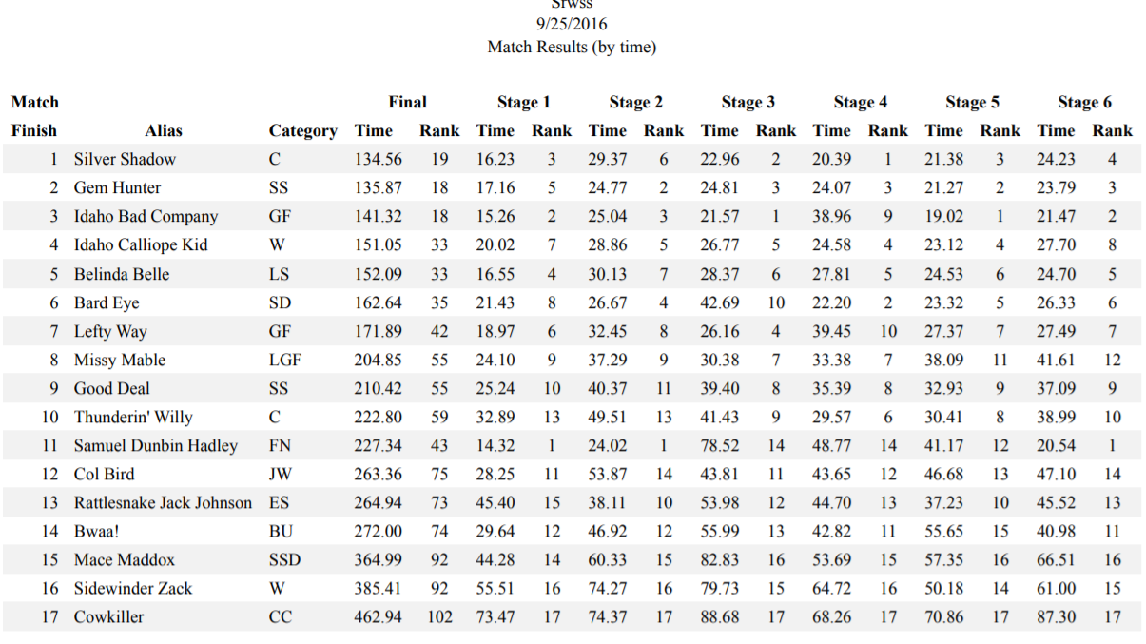
September 18, 2016
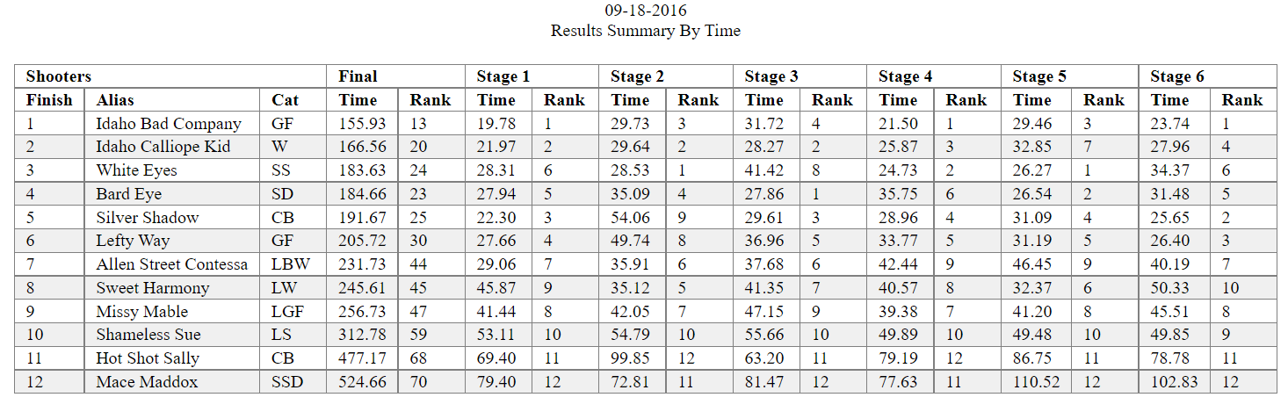
August 27, 2016
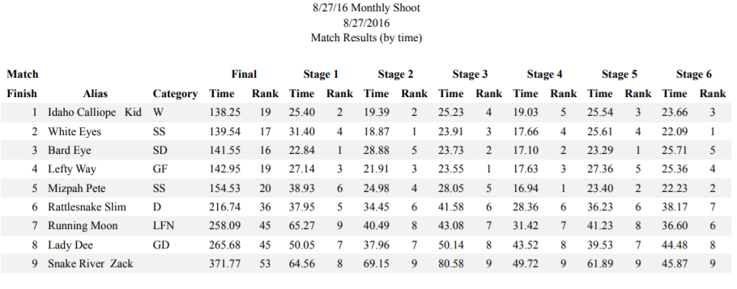
July 23, 2016
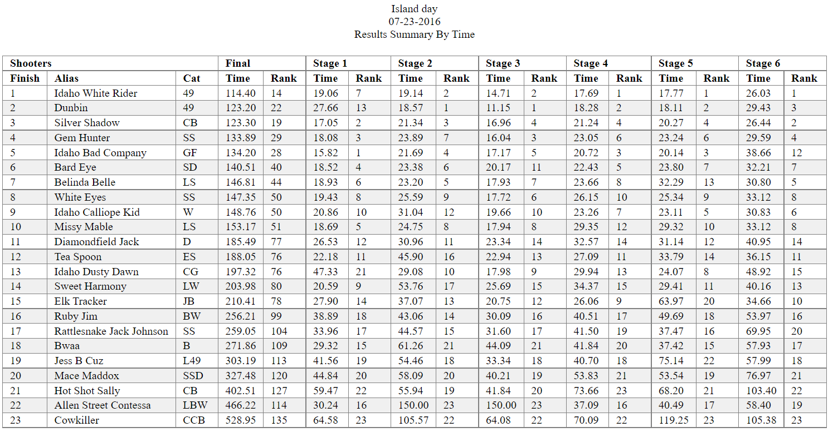
July 17, 2016
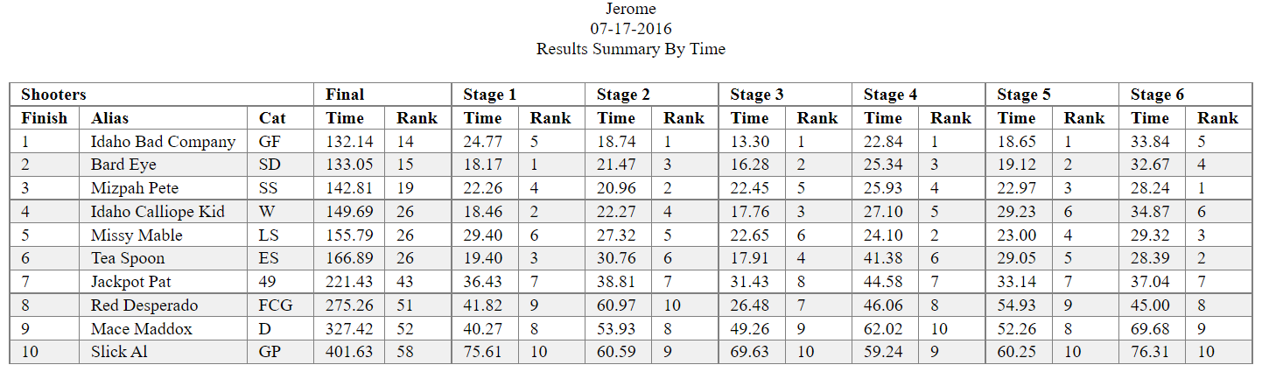
June 25, 2016
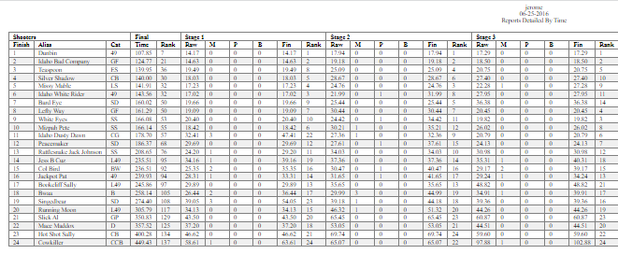
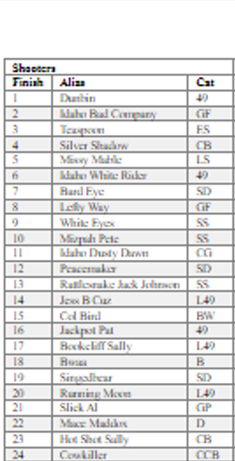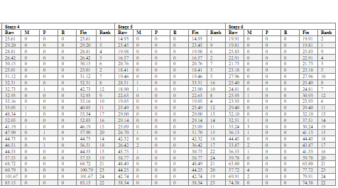
June 19, 2016
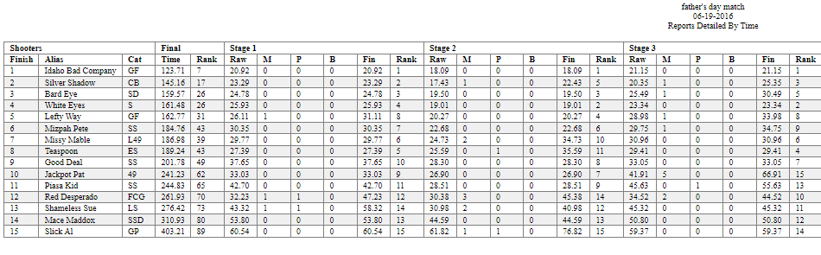
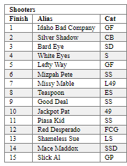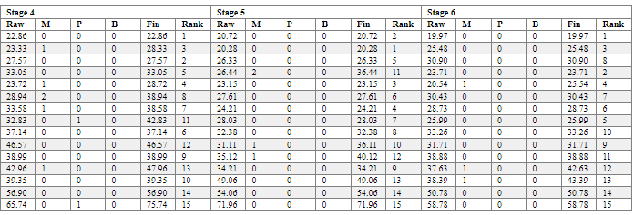
April 17, 2016
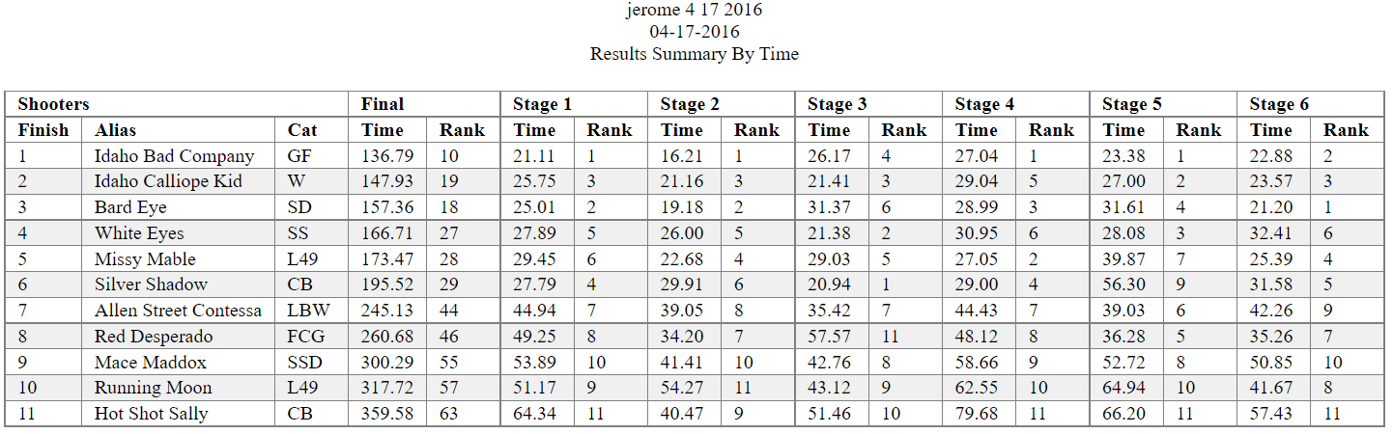
March 26, 2016
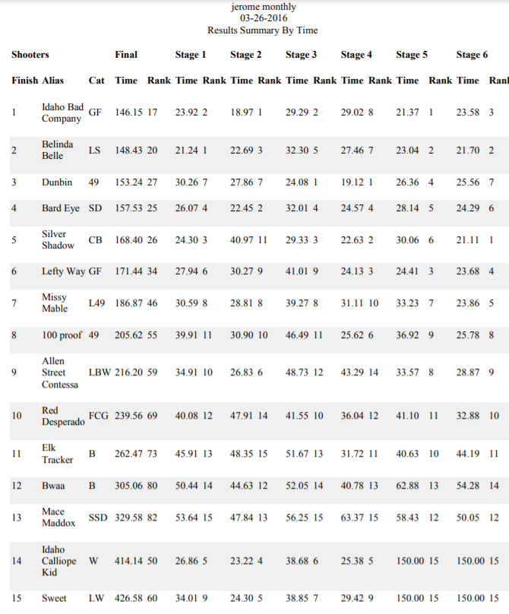
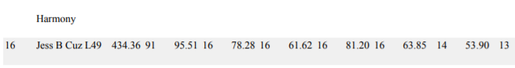
March 20, 2016
