SNAKE RIVER WESTERN SHOOTING SOCIETY
2018 – WEEKEND SHOOT SCORES
Newest to Oldest
November 10, 2018
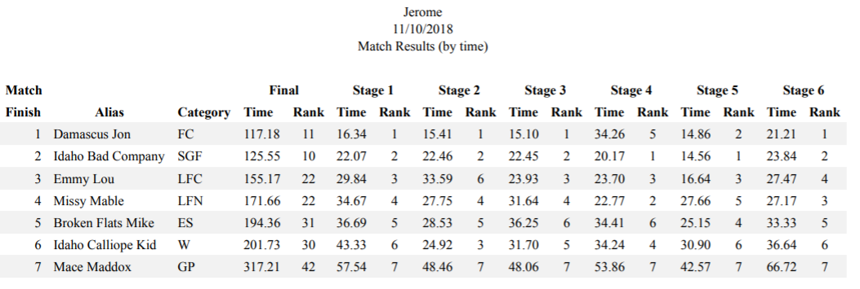
October 27, 2018
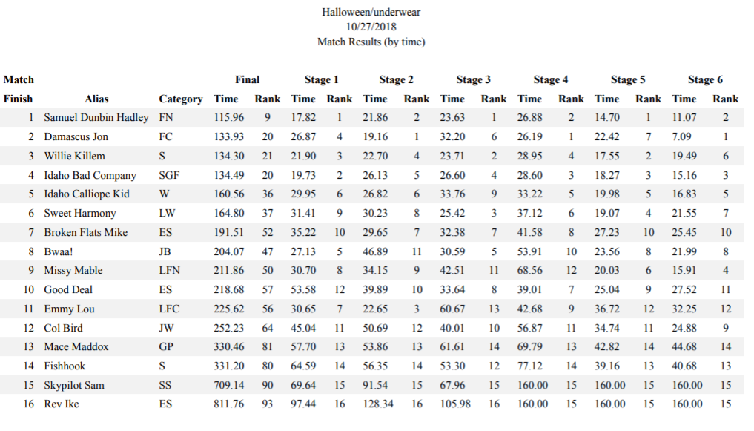
September 23, 2018
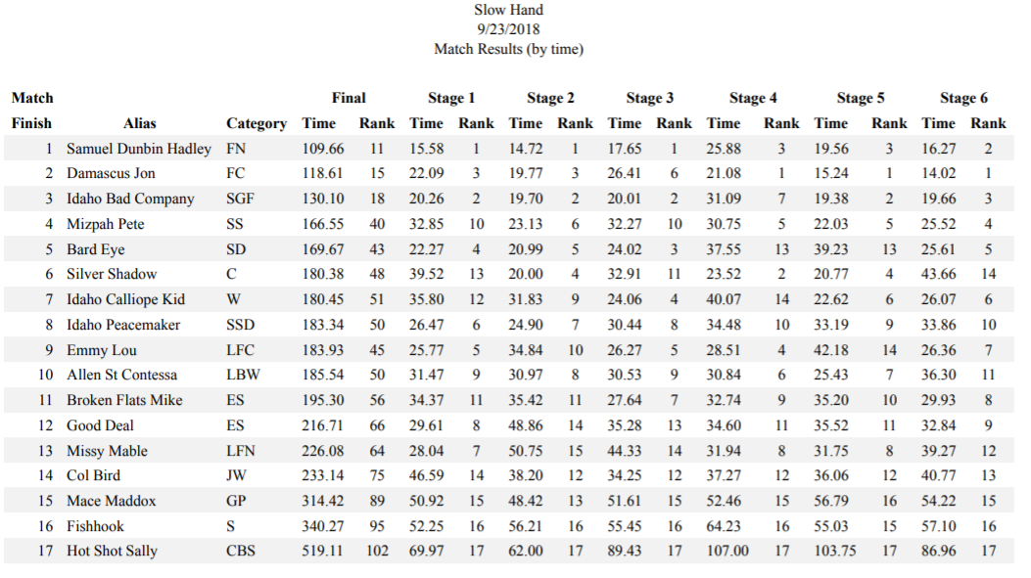
July 29, 2018
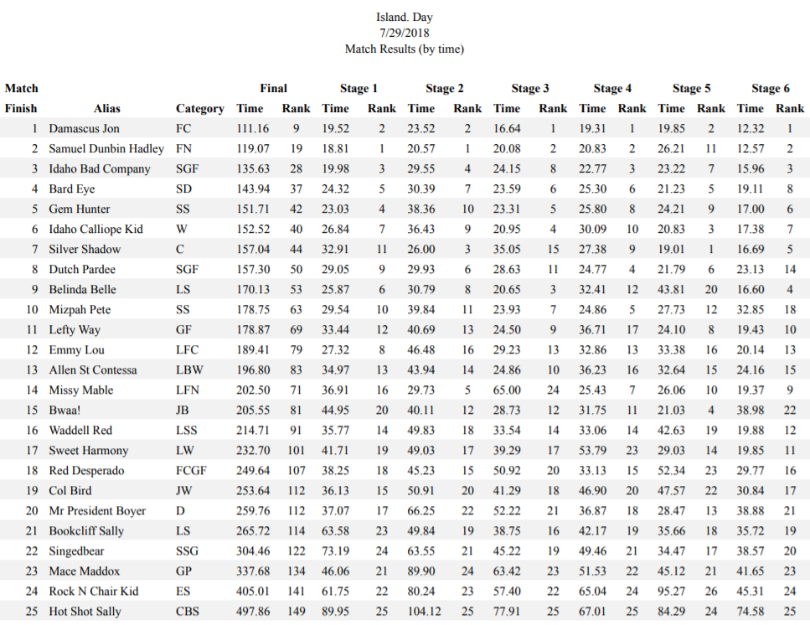
June 23, 2018
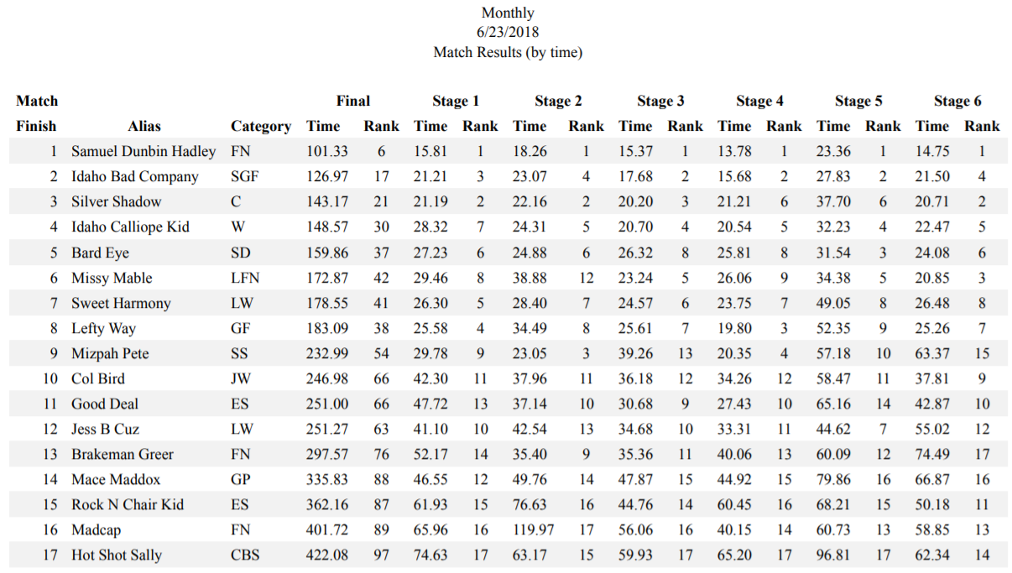
April 29, 2018
