SNAKE RIVER WESTERN SHOOTING SOCIETY
2019 – WEEKEND SHOOT SCORES
Newest to Oldest
October 12, 2018
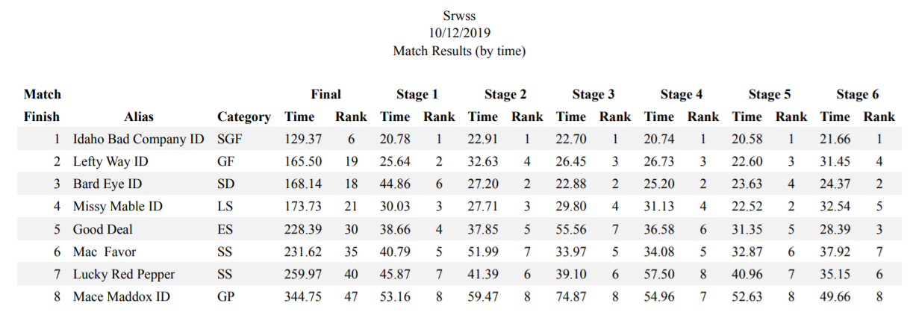
September 28, 2019
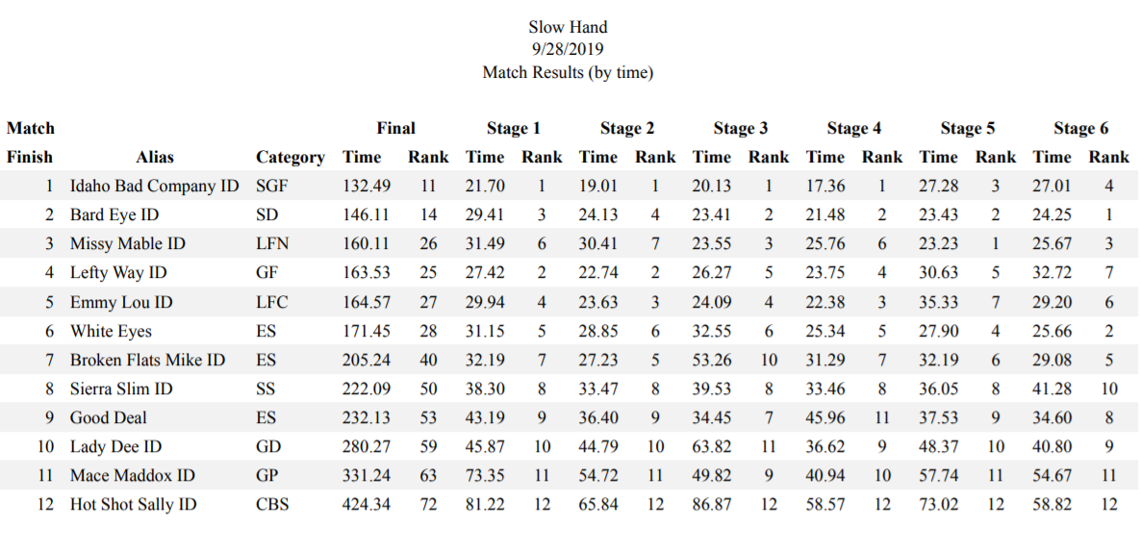
July 28, 2019
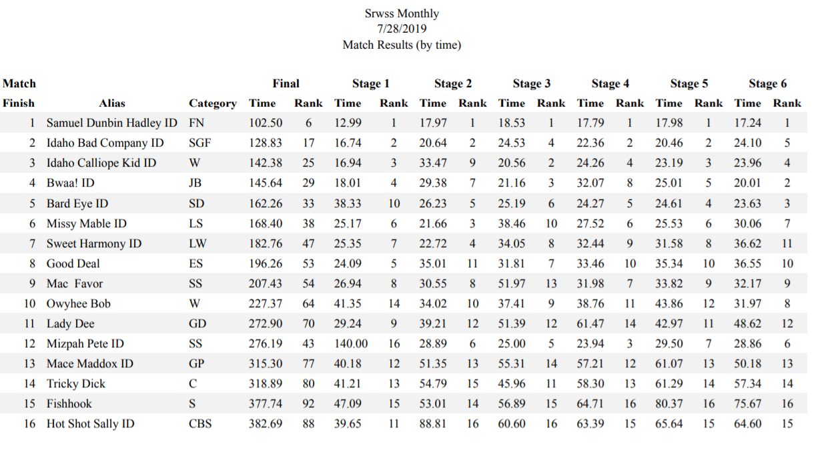
June 23, 2019
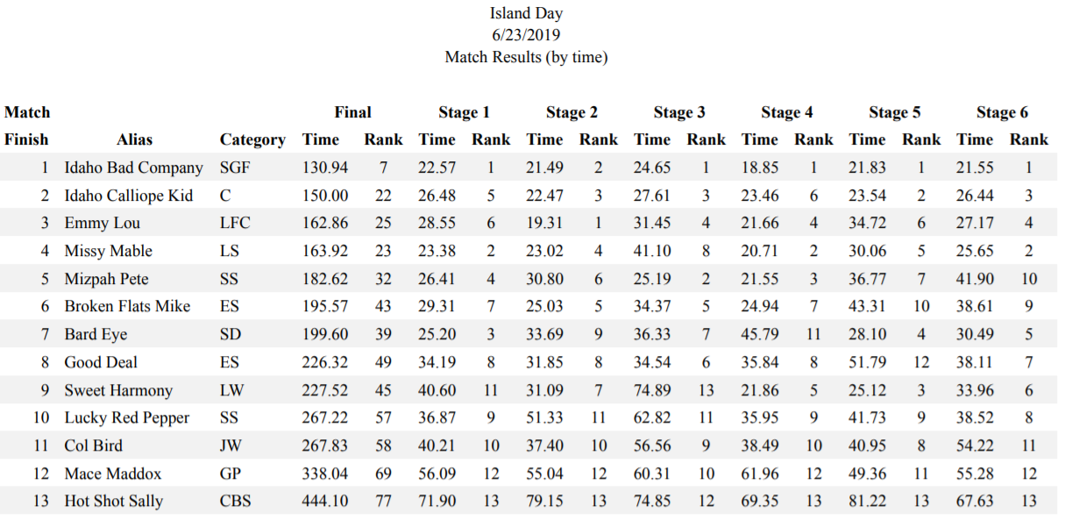
June 8, 2019
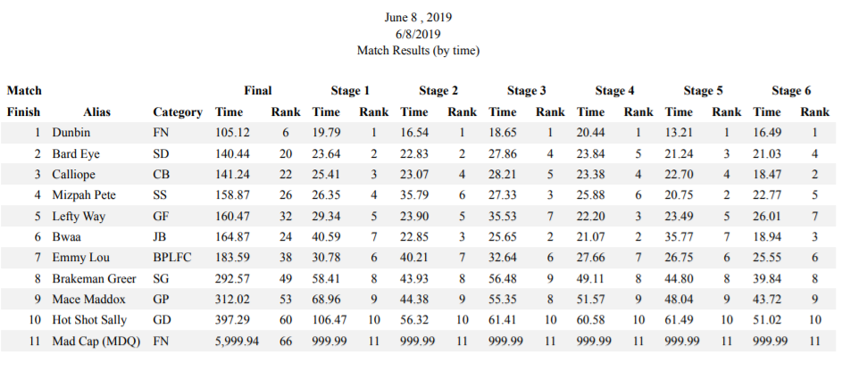
May 12, 2019
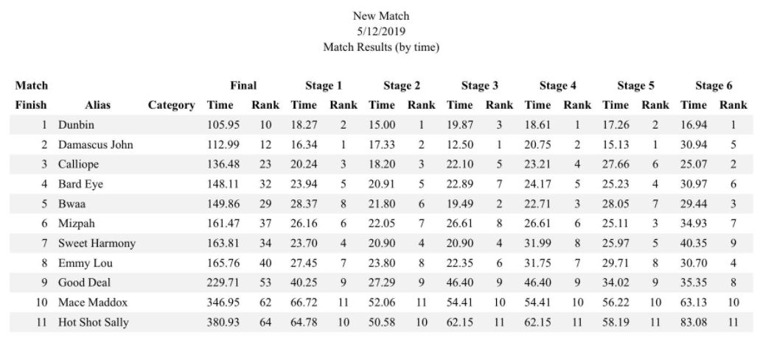
April 27, 2019
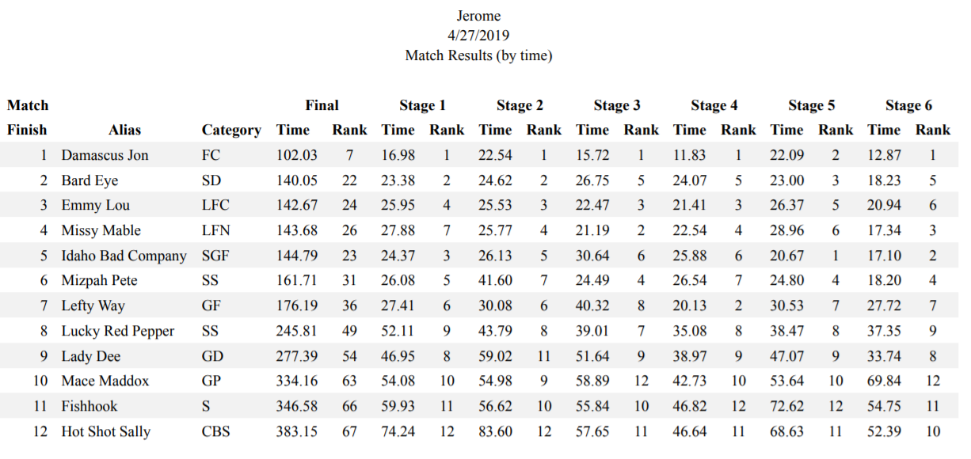
April 13, 2019
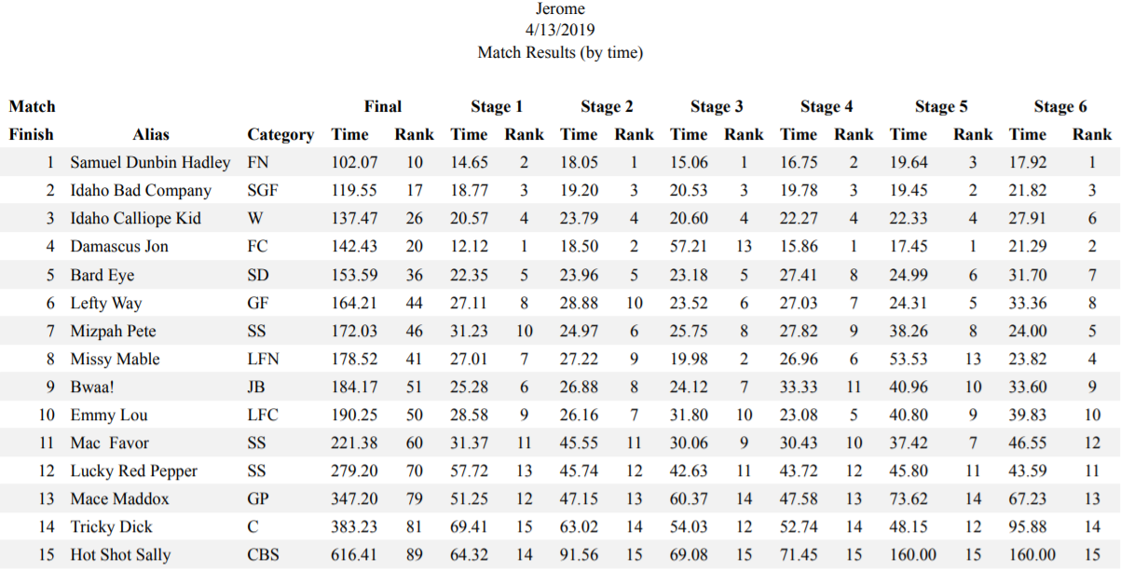
March 23, 2019
