SNAKE RIVER WESTERN SHOOTING SOCIETY
2012 – WEEKEND SHOOT SCORES
Newest to Oldest
November 24, 2012
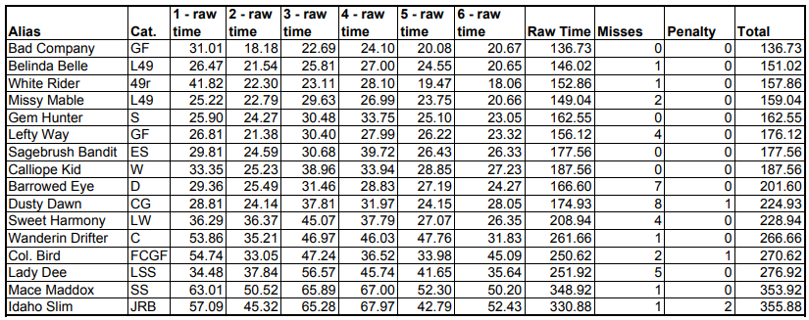
October 27, 2012
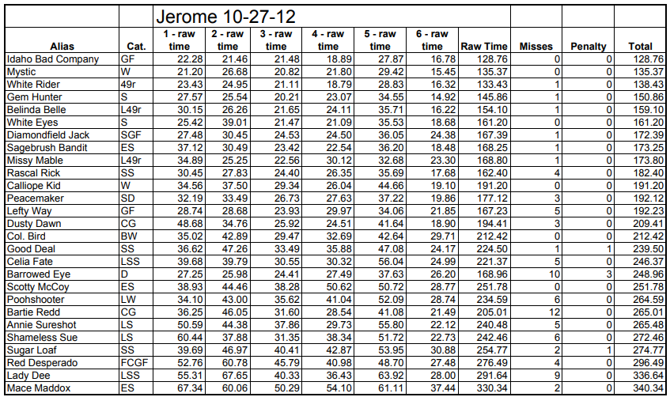
September 22, 2012
September 16, 2012
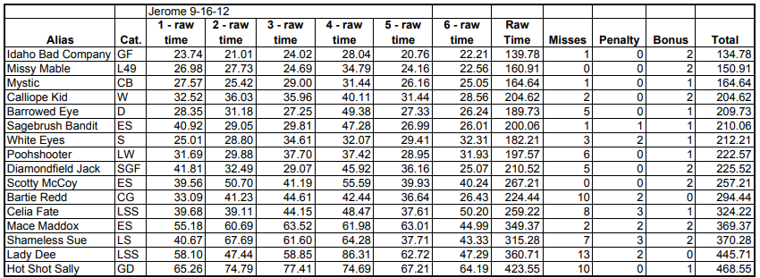
August 25, 2012
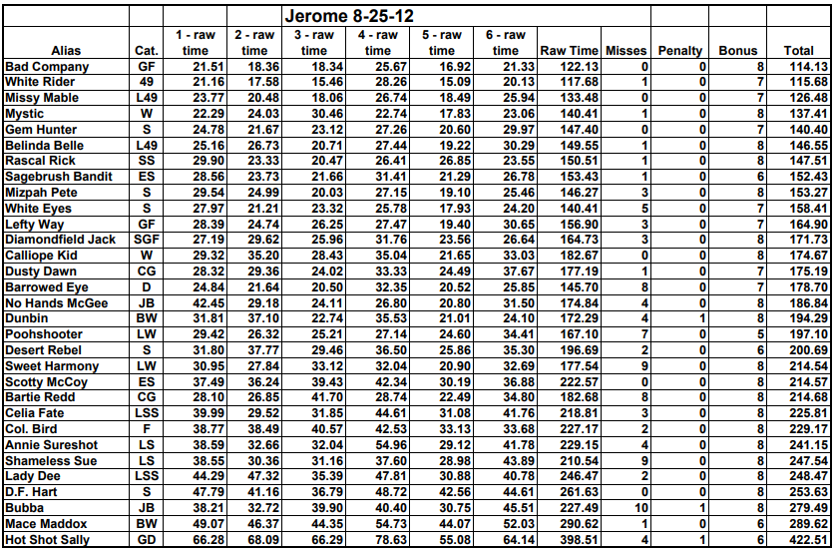
August 20, 2012
July 28, 2012
July 7, 2012
June 23, 2012
June 17, 2012
May 20, 2012
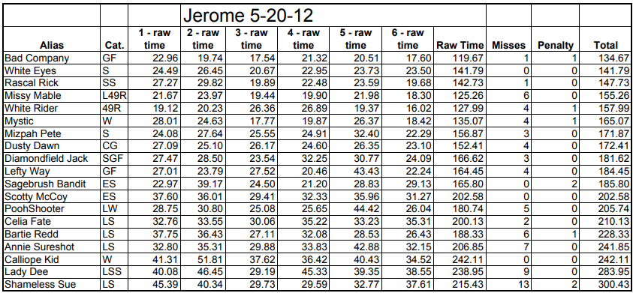
March 28, 2012
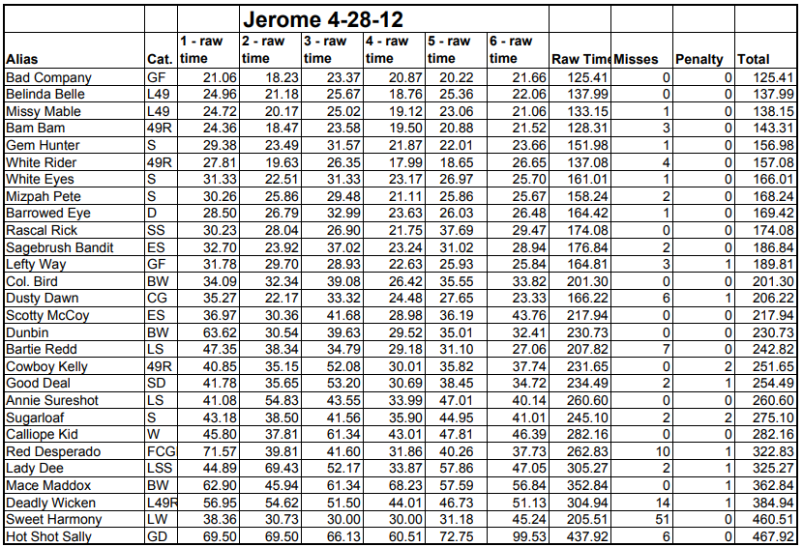
March 15, 2012
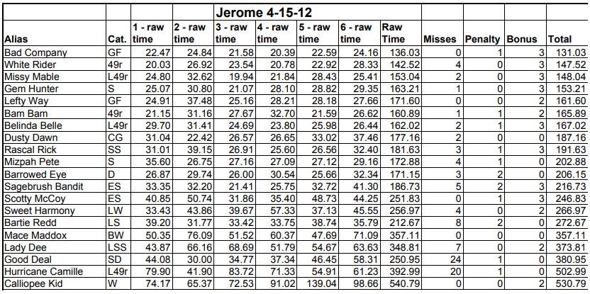
March 24, 2012
