SNAKE RIVER WESTERN SHOOTING SOCIETY
2017 – WEEKEND SHOOT SCORES
Newest to Oldest
October 28, 2017
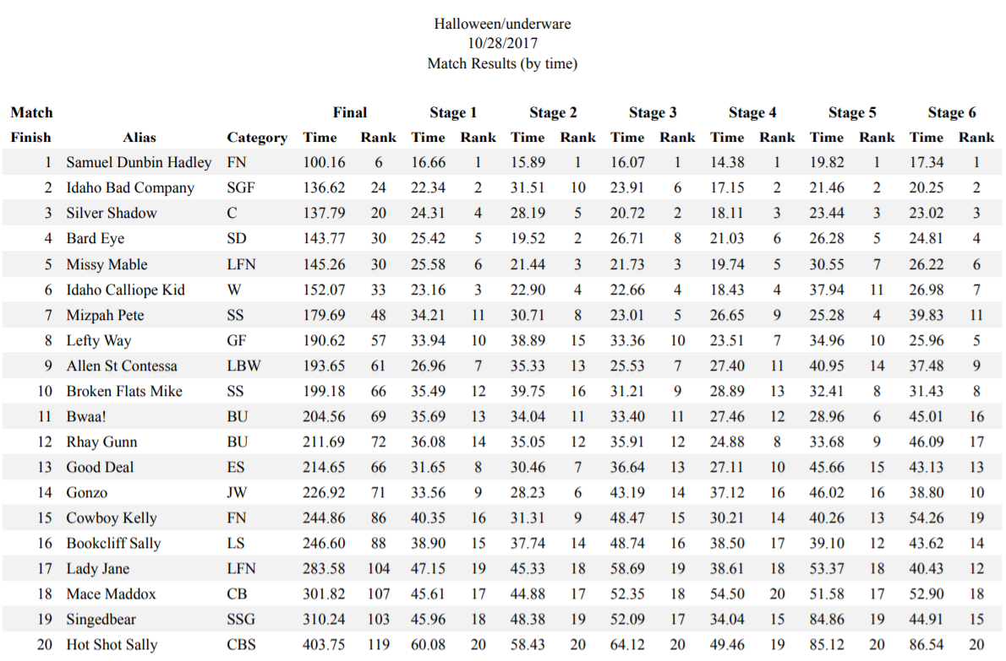
September 23, 2017
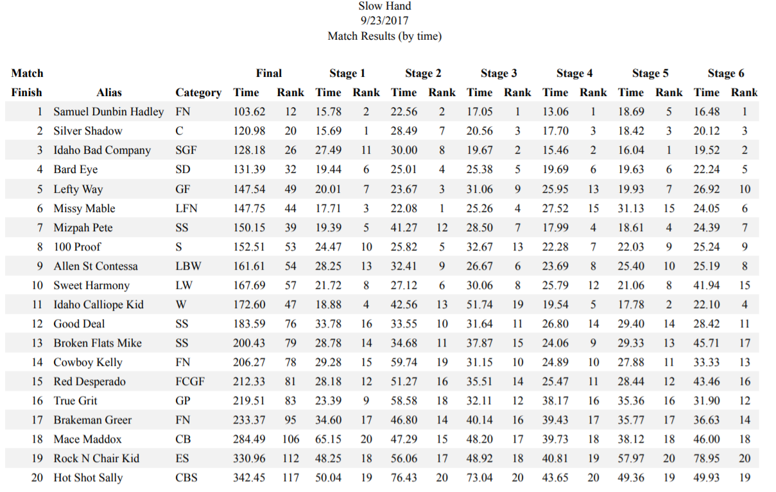
August 27, 2017
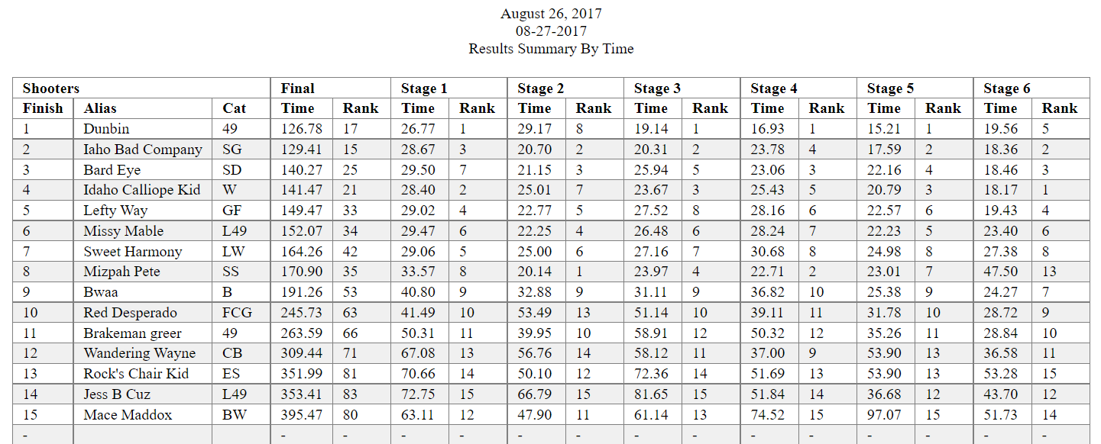

July 22, 2017
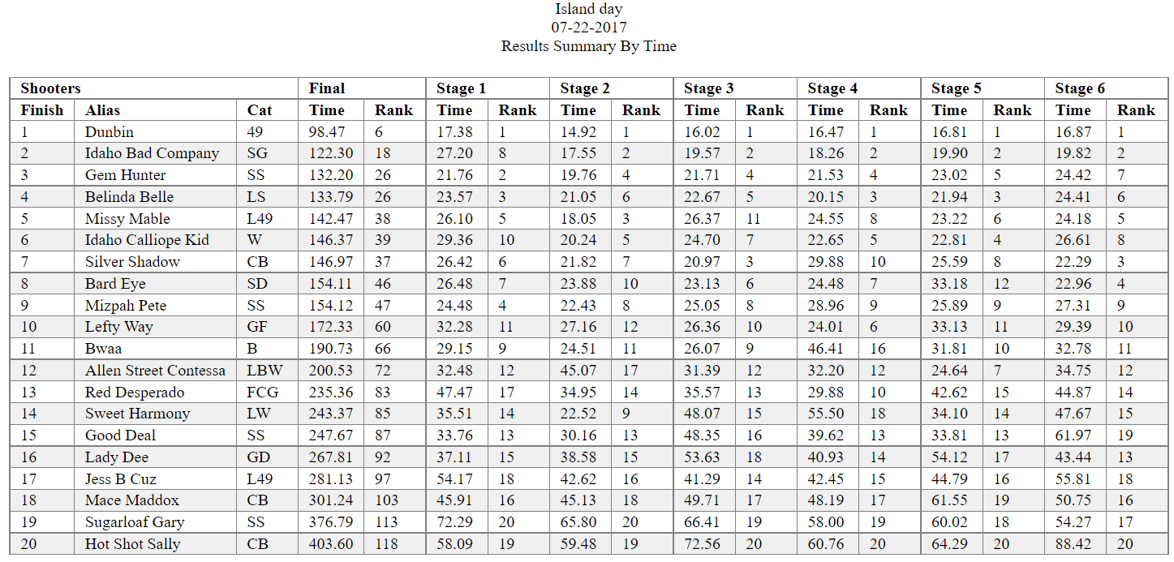
June 24, 2017
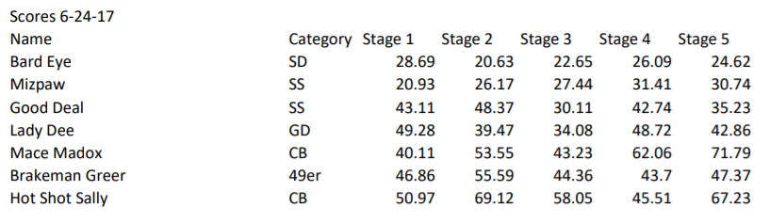
May 21, 2017
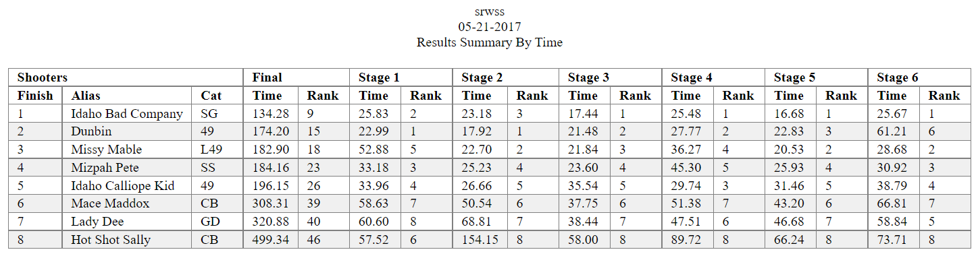
April 22, 2017
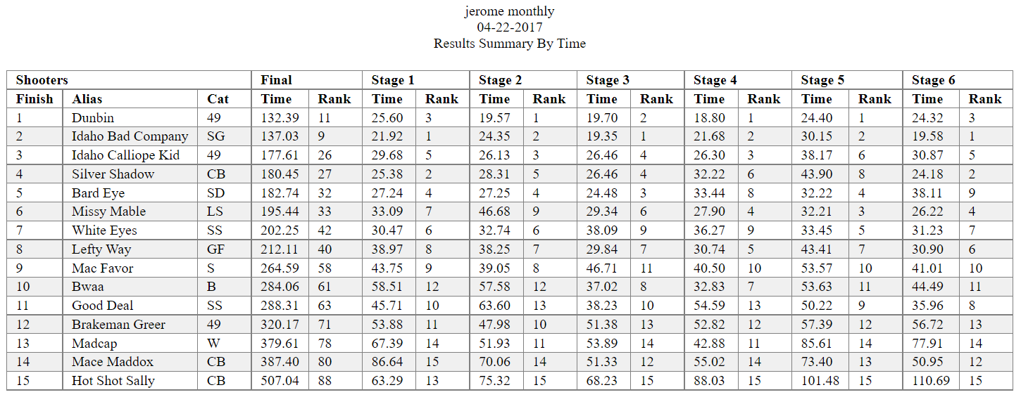
March 25, 2017
