SNAKE RIVER WESTERN SHOOTING SOCIETY
2020 – WEEKEND SHOOT SCORES
Newest to Oldest
October 31, 2020
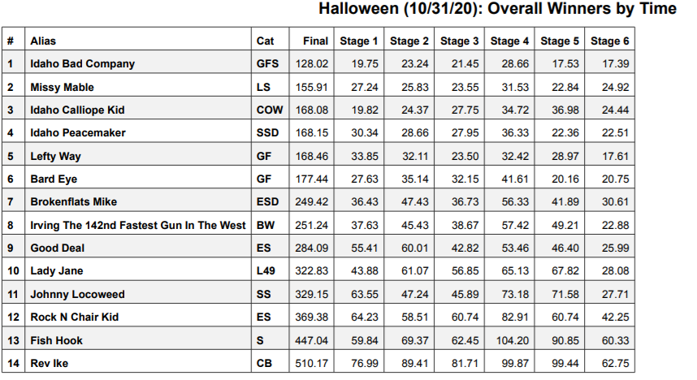
September 27, 2020
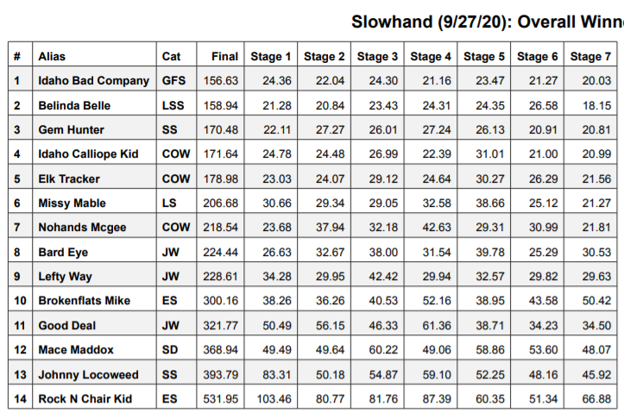
July 25, 2020
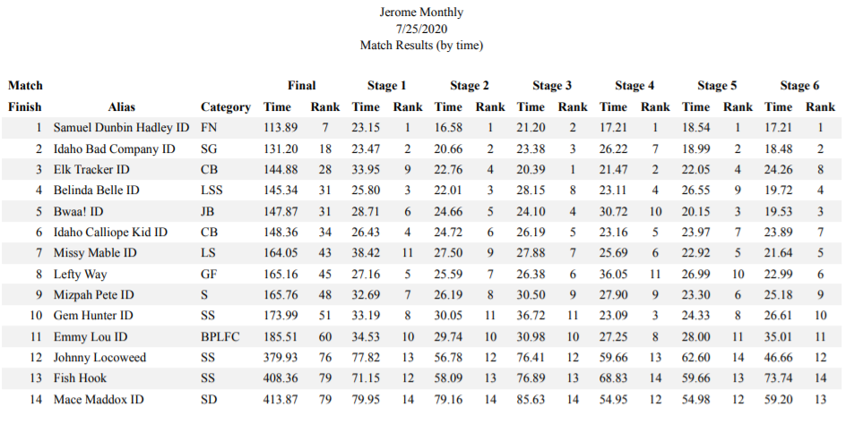
June 27, 2020
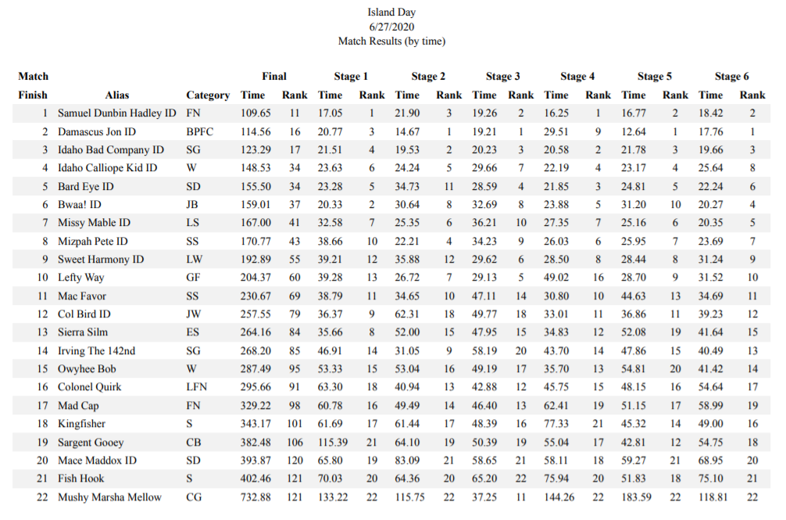
June 13, 2020
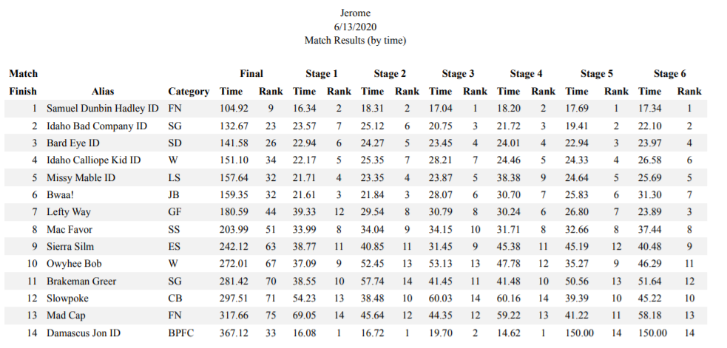
May 30, 2020
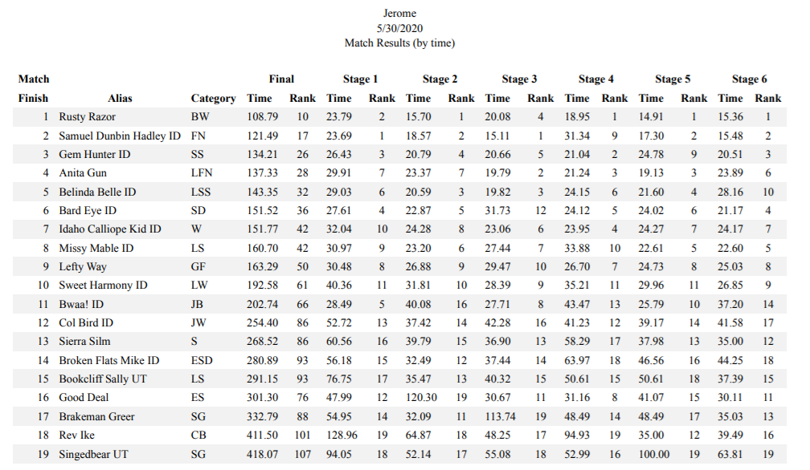
February 22, 2020
