SNAKE RIVER WESTERN SHOOTING SOCIETY
2021 – WEEKEND SHOOT SCORES
Newest to Oldest
November, 2021
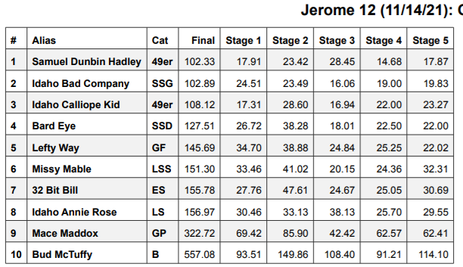
October 28, 2021
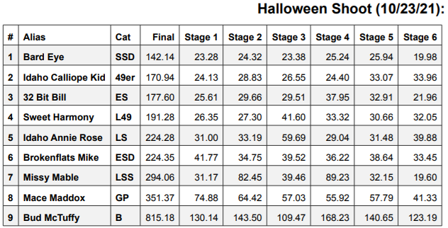
September 25, 2021
5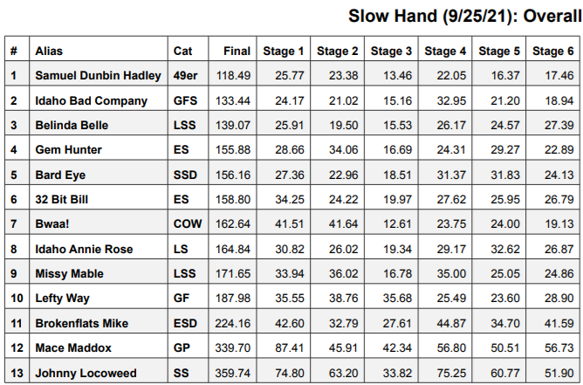
July 24, 2021
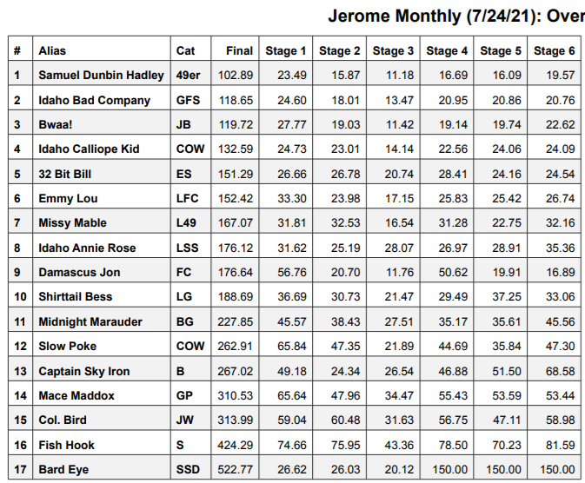
June 26, 2021
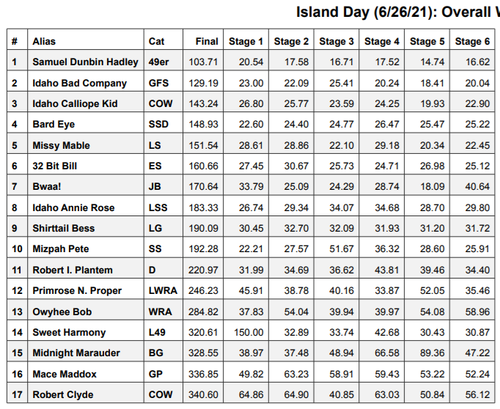
May 8, 2021
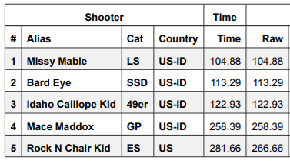
March 27, 2021
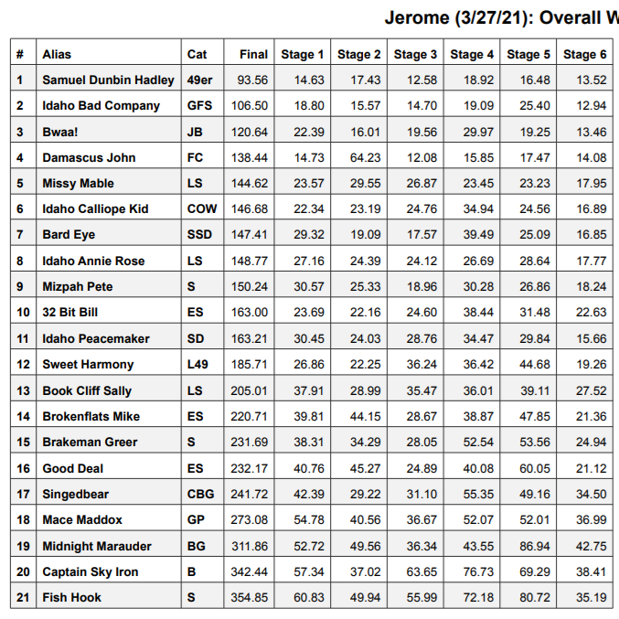
March 13, 2021
